**The Tableau HR Scorecard: Measuring Success in Talent Management**

1. **INTRODUCTION** 
   1. **Overview :**

The Project, Titled “Measuring Success in Talent Management “, is a framework designed to measure and evaluate the success of talent management strategies within an organization. It provides a way for HR professionals and business leaders to track and analyze key performance indicators (KPIs) related to workforce planning, recruitment, retention, and development.

* 1. **Purpose :**

The purpose of this project is to measure success in talent management, several key performance indicators and metrics can be utilized to assess the effectiveness of talent management initiatives

* **Assessing Talent Acquisition**: Effective talent management starts with hiring the right people. Metrics such as time-to-fill, cost per hire, and quality of hire can be used to evaluate the efficiency and effectiveness of the recruitment process.
* **Employee Retention**: High turnover can be costly and disruptive. Monitoring turnover rates and conducting exit interviews can help identify issues that might be causing employees to leave, and measure the success of retention strategies.
* **Performance Management**: Evaluating employee performance is critical in talent management. Performance appraisals and the achievement of performance goals can be used to gauge the effectiveness of performance management systems.
* **Employee Development**: Employee development is a core component of talent management. Assessing training and development programs, as well as tracking the growth and progression of employees, can indicate success in this area.
* **Employee Engagement**: Engaged employees tend to be more productive and committed. Employee engagement surveys and measures can help assess the level of engagement within the organization.
* **Succession Planning**: Effective succession planning is a key aspect of talent management. It involves identifying and developing potential future leaders within the organization. Succession planning metrics can evaluate the readiness of the talent pipeline.
* **Diversity and Inclusion**:Promoting diversity and inclusion is vital in talent management. Metrics related to the diversity of the workforce and the effectiveness of inclusion initiatives can be used to measure success in this area.
* **Talent Development ROI**: Measuring the return on investment (ROI) for talent management initiatives can provide a clear picture of whether the resources invested in employee development, training, and other programs are paying off.

Overall, this project to measure success in talent management effectively, organizations should establish clear, measurable goals and regularly track and assess these key performance indicators. By doing so, they can make data-driven decisions to continuously improve their talent management practices and ensure they have the right people in place to drive organizational success.

1. **PROBLEM DEFINITION & DESIGN THINKING** 
   1. **Empathy Map :**

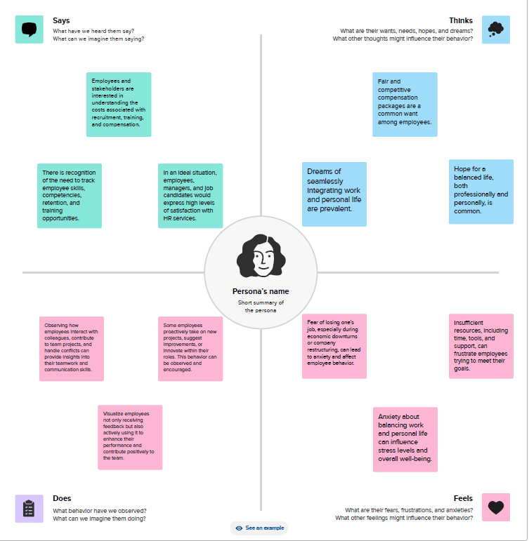

* 1. **Ideation & Brainstorming Map** :

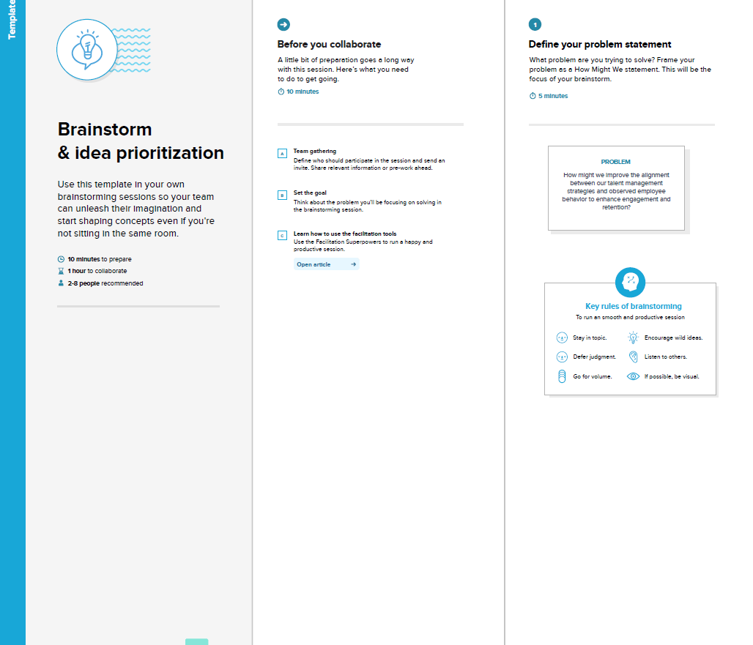

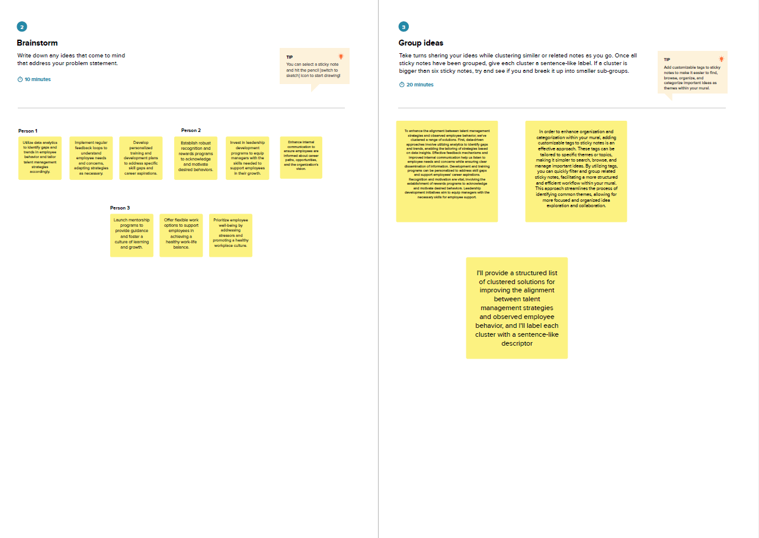

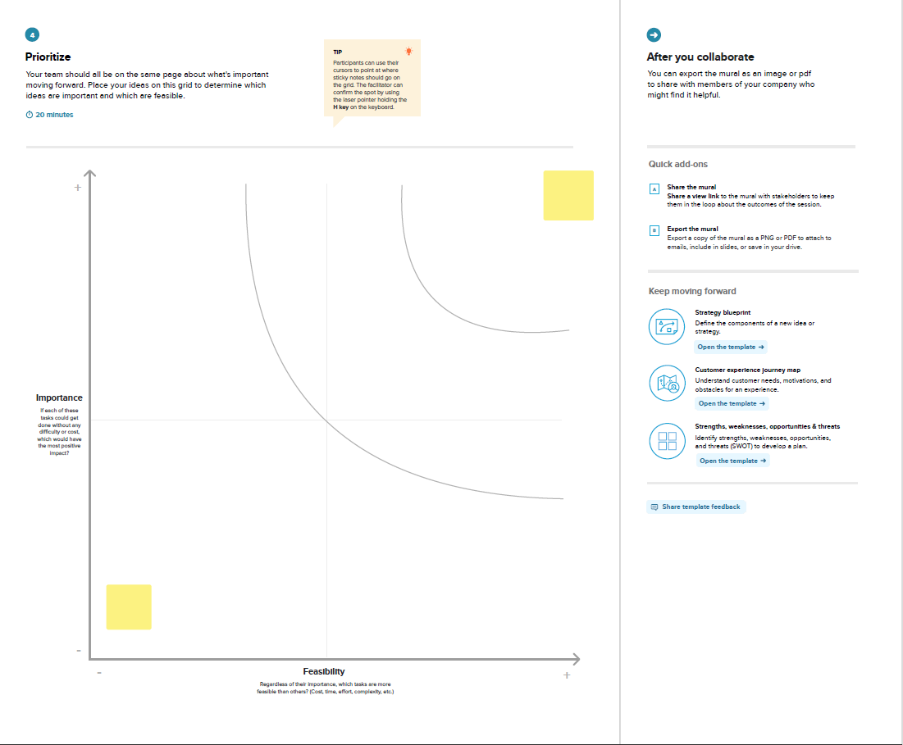

1. **RESULT** 
   1. **Dashboard :**

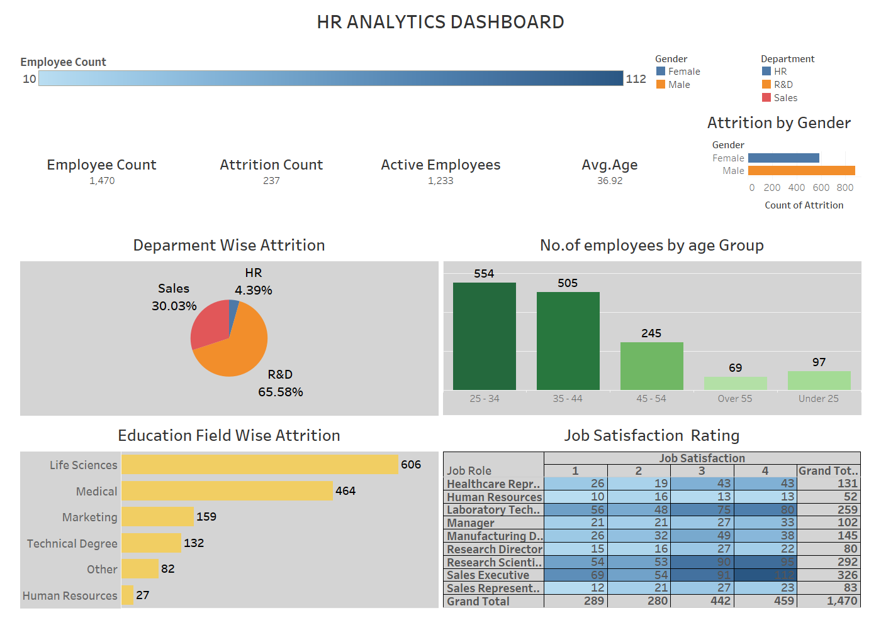

* 1. **Story :**
* HR Analytics Storyline

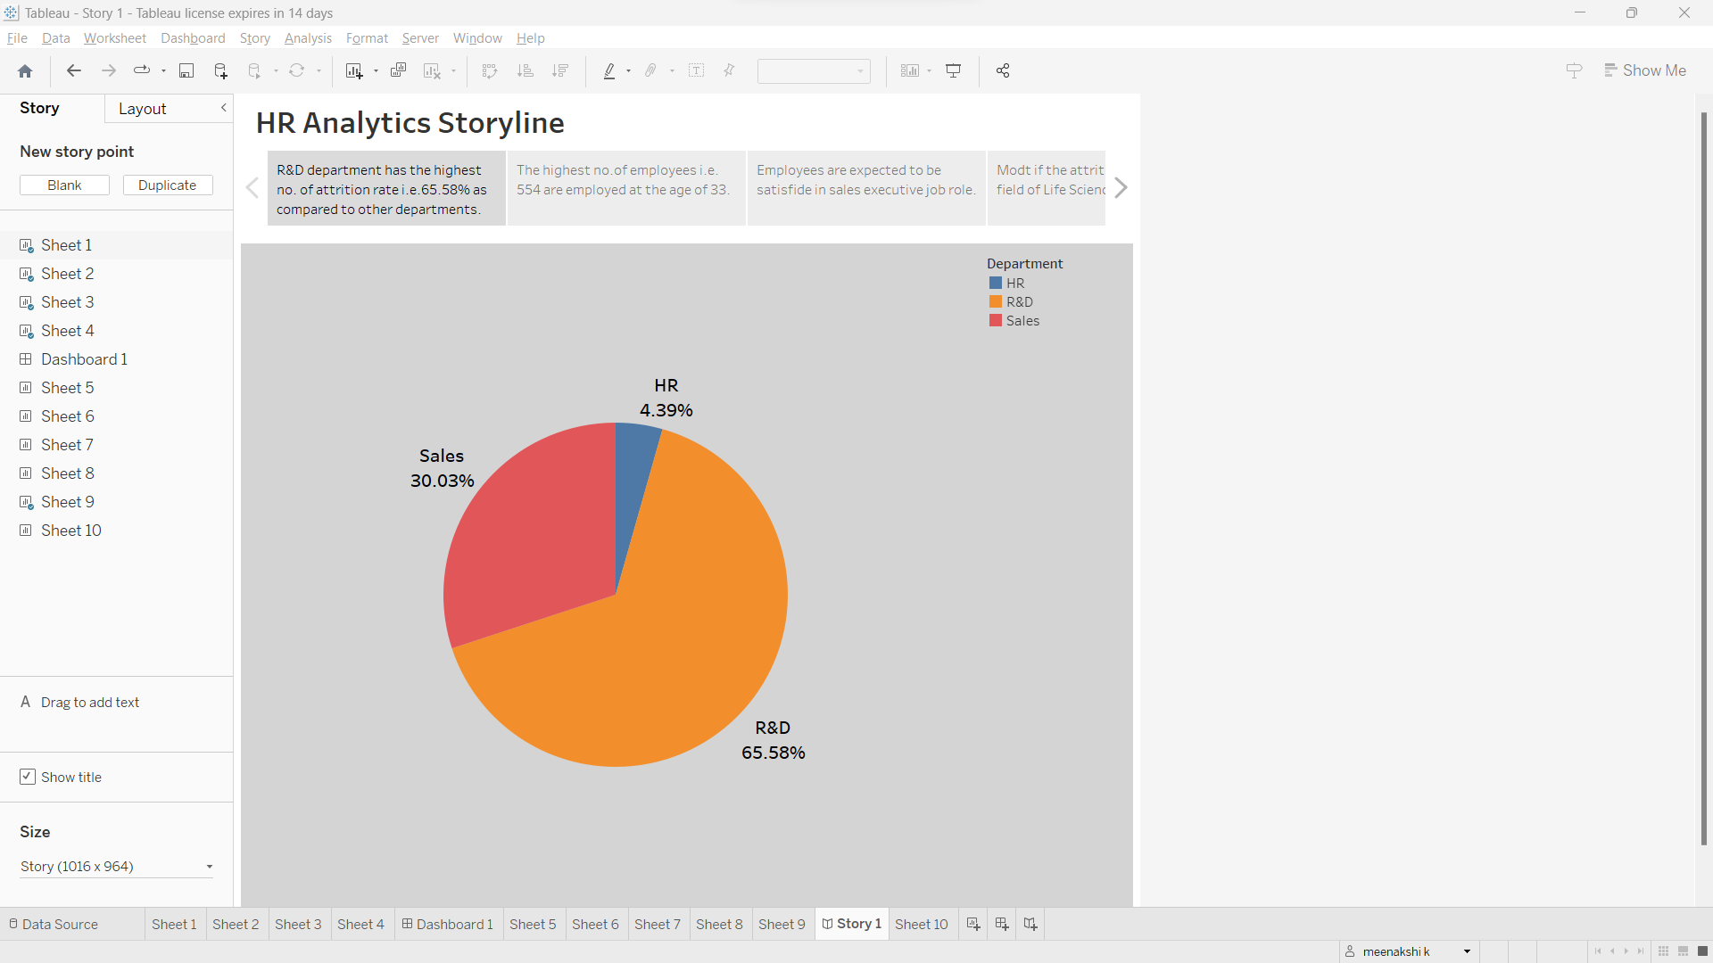

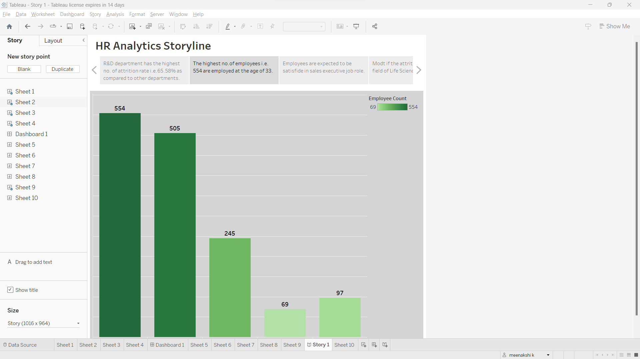

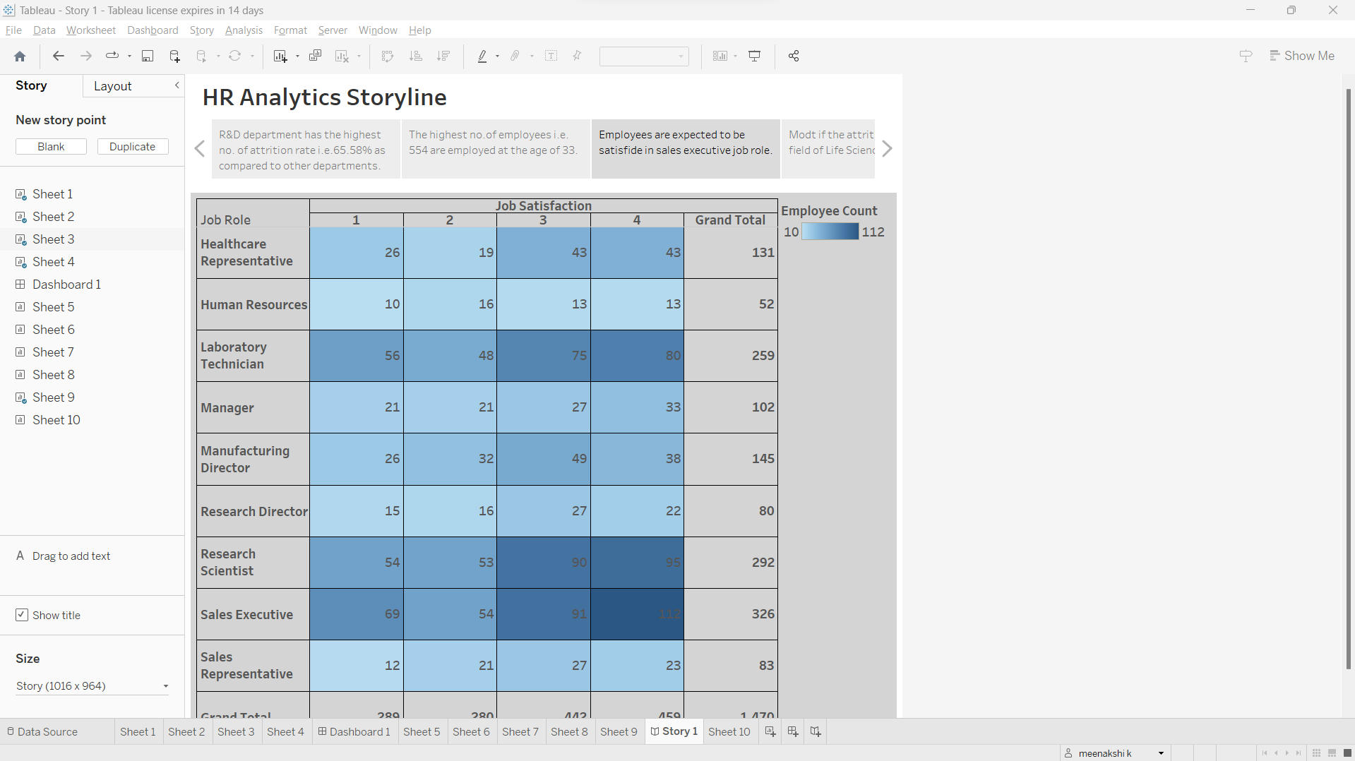

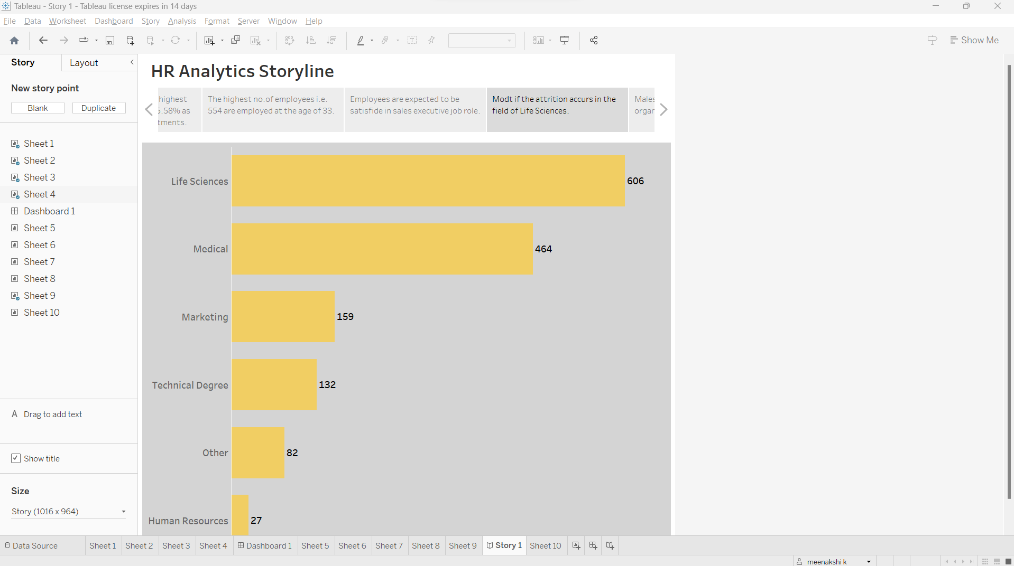

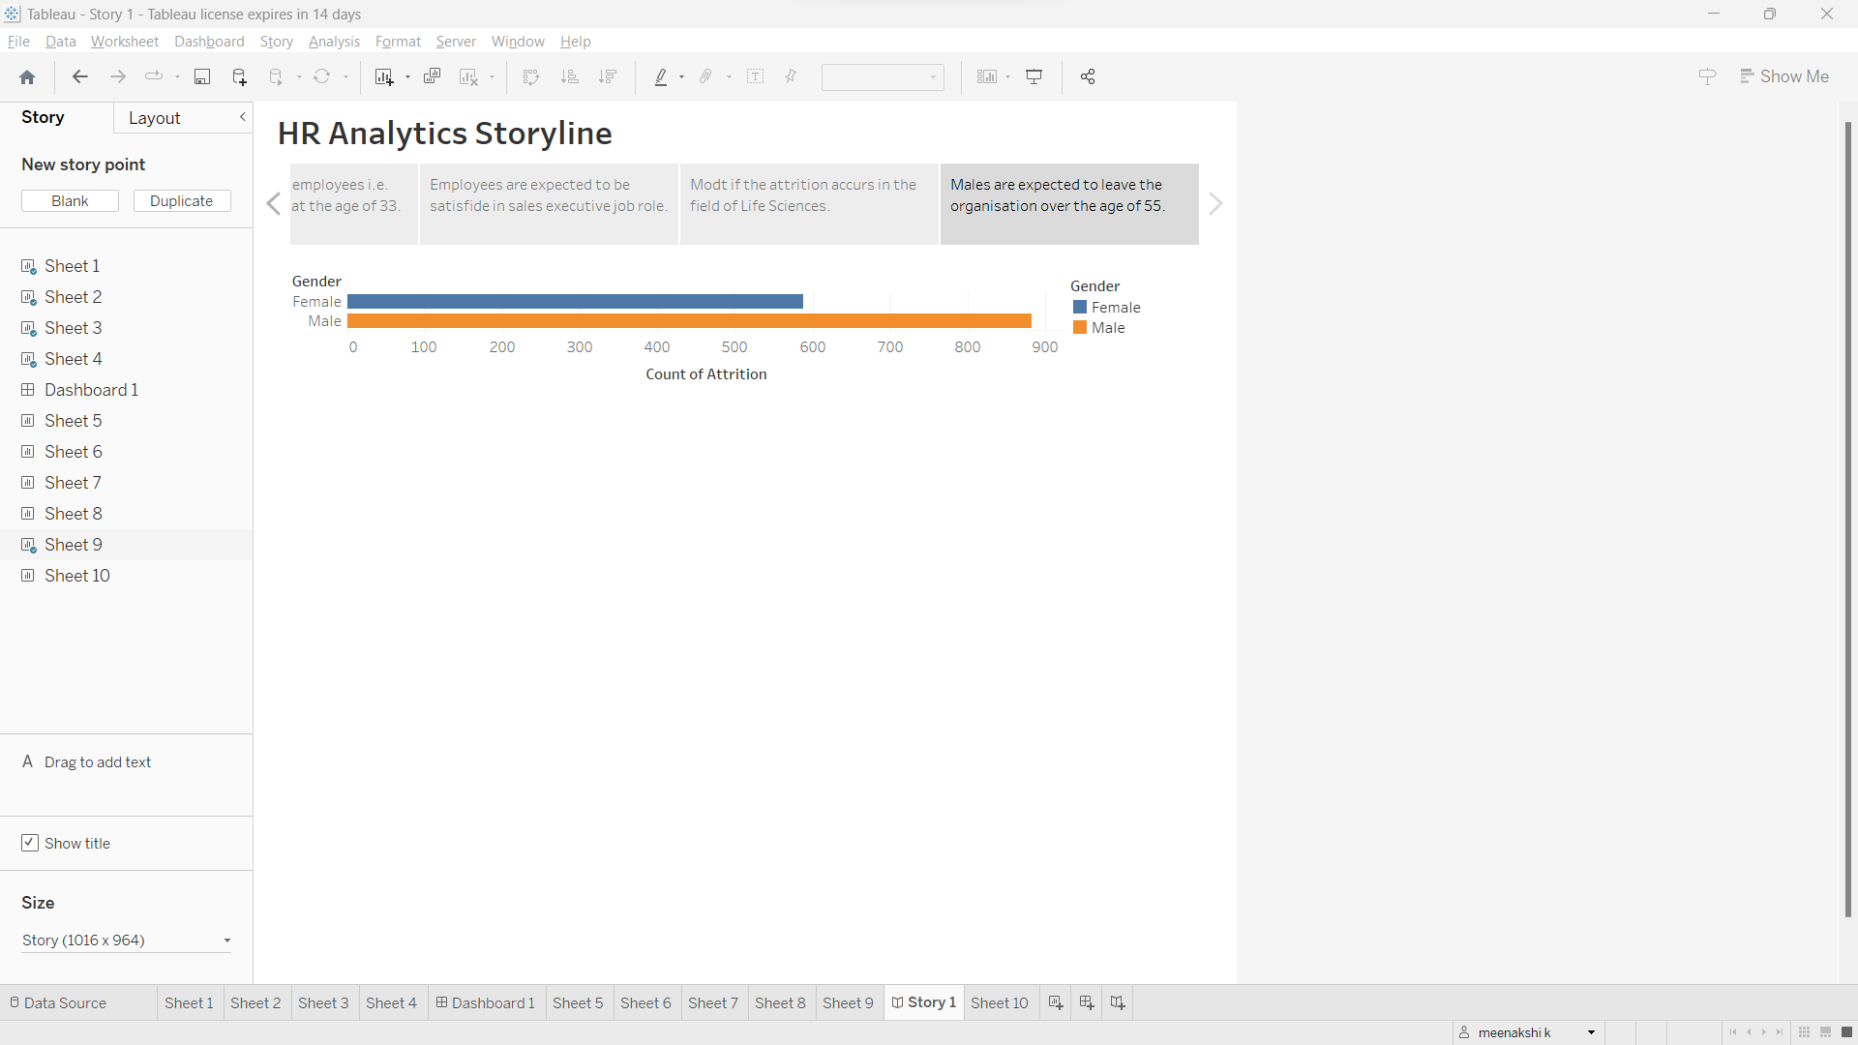

1. **ADVANTAGES & DISADVANTAGES** 
   1. **Advantages :**

Measuring success in talent management offers several advantages to organizations, as it provides a structured and data-driven approach to human resources and workforce management.

* **Strategic Alignment**: It ensures that talent management efforts are aligned with the organization's strategic goals. By measuring success, companies can confirm that they are investing resources in areas that directly contribute to their business objectives.
* **Improved Decision-Making**: Data-driven insights from talent management metrics enable better decision-making. Organizations can identify areas of strength and weakness, make informed adjustments, and allocate resources more effectively.
* **Enhanced Employee Retention**: By measuring success in talent management, organizations can pinpoint factors contributing to high turnover and implement targeted retention strategies. This can lead to a more stable and loyal workforce.
* **Increased Employee Engagement**: Metrics related to employee engagement can help identify areas where employees may be disengaged, enabling the organization to take corrective actions to improve workplace satisfaction and productivity.
* **Competitive Advantage**: An effective talent management system can give an organization a competitive edge by ensuring it has the right people with the right skills and competencies in place to respond to changing market conditions.
* **Continuous Improvement**: Regular measurement and analysis of talent management metrics encourage a culture of continuous improvement and adaptability. It allows organizations to evolve their HR practices to meet changing business needs.
  1. **Disadvantages :**

it's also important to be aware of potential disadvantages and challenges associated with this practice.

* **Data Accuracy and Reliability**: The accuracy of the data collected and the reliability of the metrics used can be a significant challenge. Inaccurate or incomplete data can lead to misguided decisions and actions.
* **Overemphasis on Quantitative Metrics**: Relying too heavily on quantitative metrics may lead to a narrow focus on easily measurable factors while neglecting qualitative aspects of talent management, such as employee morale and cultural fit.
* **Time and Resource Intensive**: Implementing a robust talent management measurement system requires time and resources. Collecting, analyzing, and reporting data can be labor-intensive, which may divert resources from other critical HR activities.
* **Short-Term Focus**: Metrics often emphasize short-term goals, such as meeting quarterly performance targets, which may not align with long-term talent development and organizational sustainability.
* **Resistance to Change**: Some employees and managers may resist the introduction of talent management metrics, perceiving them as additional bureaucracy or a departure from established practices.
* **Costs and ROI**: Implementing talent management metrics can be costly, and it may take time to realize a return on investment. The benefits may not always be immediately apparent.

1. **APPLICATIONS**

These applications are essential for optimizing human capital, aligning talent strategies with business objectives, and ensuring the long-term success of an organization.

**1 Recruitment and Selection**:

Identifying the most effective sources for talent acquisition.

Evaluating the quality of hires to ensure they align with organizational needs and goals.

Reducing time-to-fill and cost-per-hire by refining recruitment processes.

**2 Employee Onboarding**:

Measuring the effectiveness of onboarding processes by tracking employee engagement and retention during the initial period.

Identifying areas for improvement in orientation and training.

**3 Performance Management**:

Assessing employee performance through key performance indicators (KPIs) and goal achievement.

Providing feedback to employees and managers for development and career planning.

**4 Employee Development**:

Evaluating the return on investment (ROI) for training and development programs.

Identifying skill gaps and employee development needs.

Tracking employee progress in skill development and career advancement.

**5 Employee Engagement**:

Measuring employee satisfaction, motivation, and commitment through engagement surveys.

Identifying factors affecting engagement and implementing strategies to enhance it.

**6 Succession Planning:**

Assessing the readiness and potential of employees to step into key leadership positions.

Ensuring a robust pipeline of future leaders to minimize talent gaps.

**7 Talent Retention**:

Identifying turnover rates and reasons for employee departures.

Implementing retention strategies based on data-driven insights.

**8 Legal Compliance**:

Ensuring that talent management practices comply with legal and regulatory requirements, reducing the risk of legal issues and penalties.

**9 Leadership Development**:

Identifying potential leaders and assessing their growth and readiness for leadership roles.

Designing and delivering leadership development programs based on individual and organizational needs.

1. **CONCLUSTION**

In conclusion, measuring success in talent management is a multifaceted practice that provides organizations with valuable insights to optimize their workforce. To reap the benefits while mitigating challenges, organizations should strike a balance between quantitative and qualitative measures, uphold privacy and ethical standards, and maintain flexibility in their approach. By doing so, organizations can adapt to the ever-evolving business landscape and ensure their talent management practices remain aligned with their strategic objectives.